|  |  |  |  |  |  |  |  |  |  |  |  |  |  |  |  |  |  |  |  |  |  |  |  |  |  |  |  |  |  |  |  |
| --- | --- | --- | --- | --- | --- | --- | --- | --- | --- | --- | --- | --- | --- | --- | --- | --- | --- | --- | --- | --- | --- | --- | --- | --- | --- | --- | --- | --- | --- | --- | --- |
| **INTERSTATE CONTAINER CORPORATION** | | | ***Date:* 02/05/2014** | ***Spec #:*** | | | | | | | | | |  |  |  |  | ***Design #:* 131116-01_B** | | | | | | | | | | | |  |  |
|  |  |  |  |  |  |
| ***Customer:*** | **DeMet's Candy** |  |  |  |  |  |  |  |  |  |  |  |  |  |  |  |  |  |  |  |  |  |  |  |  |  |  |  |  |  |  |
|  |  |  |  |  |  |  |  |  |  |  |  |  |  |  |  |  |  |  |  |  |  |  |  |  | ***Cut*** | **245 in.** | |  |  |
|  |  |  |  |  |  |  |  |  |  |  |  |  |  |  |  |  |  |  |  |  |  |  |  |  |  |  |
| ***Description:*** | **RSC.673/0** |  |  |  |  |  |  |  |  |  |  |  |  |  |  |  |  |  |  |  |  |  |  |  |  |  |  |  |
|  |  |  |  |  |  |  |  |  |  |  |  |  |  |  |  |  |  |  |  |  |  |  |  |  | ***Crease*** | **182 in.** | |  |  |
|  |  |  |  |  |  |  |  |  |  |  |  |  |  |  |  |  |  |  |  |  |  |  |  |  |  |  |
| ***Style:* D/C RSC** |  | ***Revision Info:* [B]02/05/2014\*** | ***Salesperson:* Dennis Bethem** |  |  |  |  |  |  |  |  |  |  |  |  |  |  |  |  |  |  |  |  |  |  |  | ***1/2(cut) 1/8 perf*** | **50 in.** | |  |  |
| ***I.D. :* 17 x 12+1/4 x 10+7/8** | | ***Blank size:* 23+7/16 x 60+1/4** |  |  |  |  |  |  |  |  |  |  |  |  |  |  |  |  |  |  |  |  |  |  |  |  |  |  |  |  |
|  |  |  |  |  |  |  |  |  |  |  |  |  |  |  |  |  |  |  |  |  |  |  |  |  |  |  |  |
| ***Board:* 32 B K** |  | ***Combination:* 35HP - 23M - 35HP** | ***Designer:* Brian Romankow** | |  |  |  |  |  |  |  |  |  |  |  |  |  |  |  |  |  |  |  |  |  |  |  |  |  |  |  |
|  |  |  |  |  |  |  |  |  |  |  |  |  |  |  |  |  |  |  |  |  |  |  |  |  |  |  |

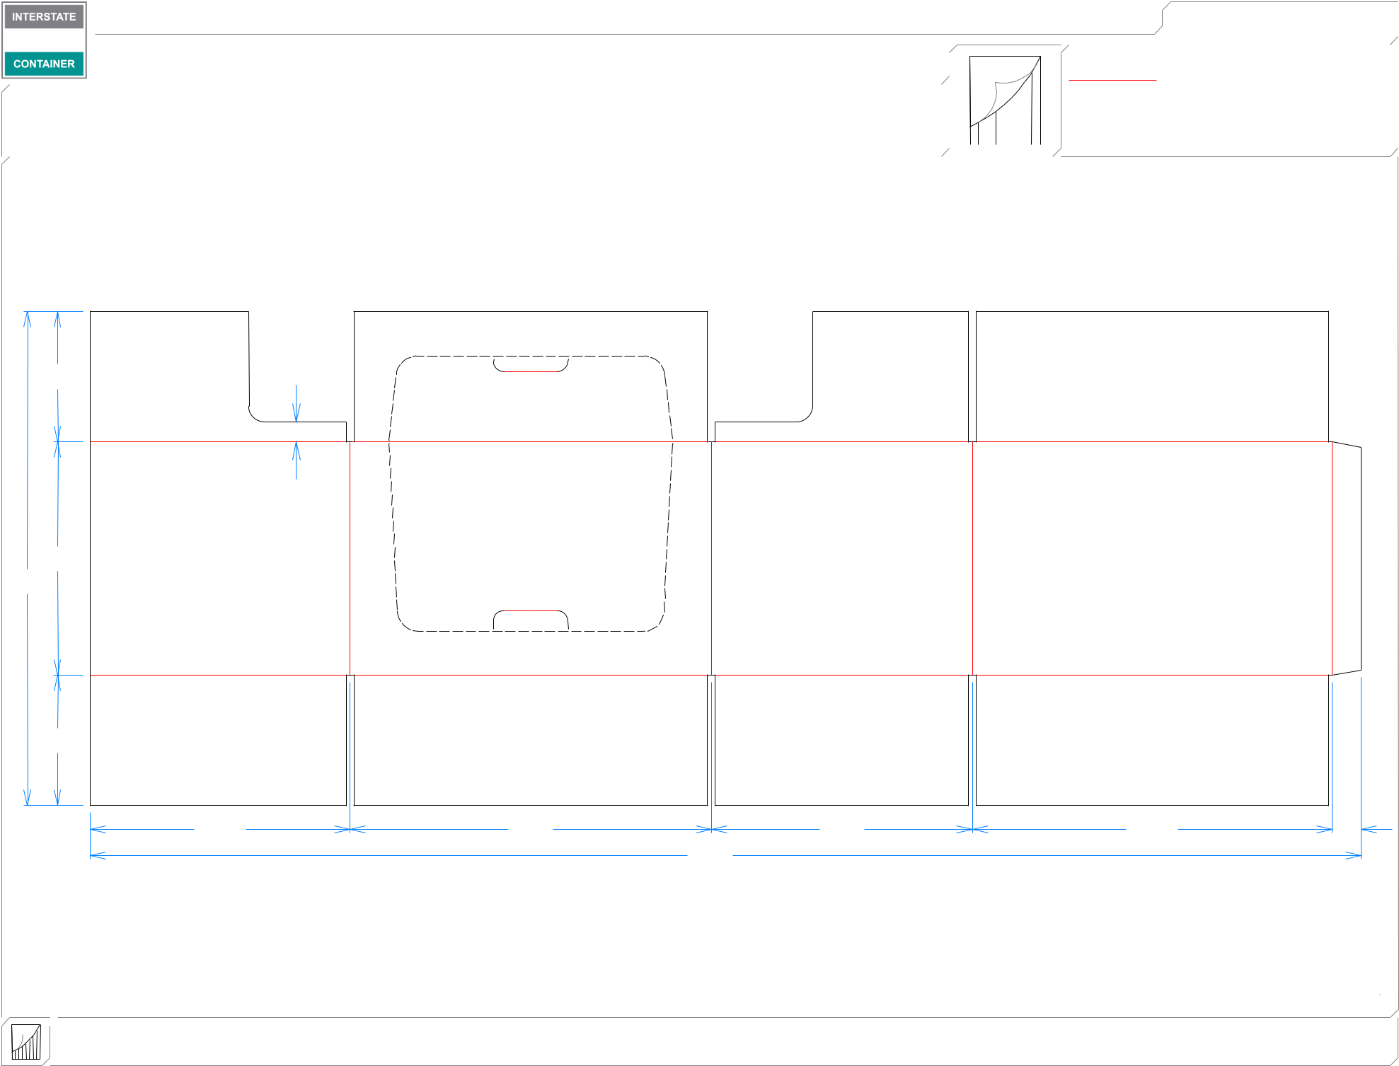

|  |  |  |  |  |
| --- | --- | --- | --- | --- |
| 63*/*16 |  |  |  |  |
|  | 15*/*16 |  |  |  |
| 111*/*16 |  |  |  |  |
| 237*/*16 |  |  |  |  |
| 63*/*16 |  |  |  |  |
| 125*/*16 | 171*/*8 | 123*/*8 | 171*/*16 | 13*/*8 |
|  |  | 601*/*4 |  |  |

**inside view**

**Vertical Corrugation**

***notes:***

***Qty/unit:*** ***Area - waste:* 9.24 sq. ft** ***Waste on blank:* 5.8%** ***Piece weight - waste:* 0.95 lbs./432.07 g**